Msdn guide for Custom Web Service:

<http://msdn.microsoft.com/en-us/library/ms464040.aspx>

**1) Add your assembly to the global assembly cache (GAC)**

- Add KispSharePoint.dll to “C:\Windows\assembly”

For future update of this dll, you need to change GAC view to folder view

Replace new dll to C:\Windows\assembly\GAC_MSIL\KispSharePoint\1.0.4.886__cf35bea022ce4543\ KispSharePoint.dll

To allow folder view in GAC

go to registry

HKEY_LOCAL_MACHINE > SOFTWARE > Microsoft > Fusion

Change / add new DWORD “DisableCacheViewer” to 1

**2)** [**Deploying the Web Service Files to the _vti_bin Directory**](javascript:void(0))

- Copy the following files into

“C:\Program Files\Common Files\Microsoft Shared\Web Server Extensions\14\ISAPI”

KispSharePointServicewsdl.aspx

KispSharePointServicedisco.aspx

KispSharePointService.asmx

SnapTrackerTemplate.wsp 🡨 right now it is a default SharePoint team site template.

**3) Listing the New Web Service in spdisco.aspx**

- Modify spdisco.aspx under location

“C:\Program Files\Common Files\Microsoft Shared\Web Server Extensions\14\ISAPI”

- Copy and paste the following code inside <discovery></<discovery> tags:

<contractRef ref=<% SPHttpUtility.AddQuote(SPHttpUtility.HtmlEncode(spWeb.Url + "/_vti_bin/KispSharePointService.asmx?wsdl"), Response.Output); %> docRef=<% SPHttpUtility.AddQuote(SPHttpUtility.HtmlEncode(spWeb.Url + "/_vti_bin/KispSharePointService.asmx"), Response.Output); %> xmlns="http://schemas.xmlsoap.org/disco/scl/" />

<discoveryRef ref=<% SPHttpUtility.AddQuote(SPHttpUtility.HtmlEncode(spWeb.Url + "/_vti_bin/KispSharePointService.asmx?disco"),Response.Output); %> xmlns="http://schemas.xmlsoap.org/disco/" />

**4) Setups for auto Login from Snaptracker to SharePoint**

Copy Kisp.SharePoint.Authentication folder into

“C:\Program Files\Common Files\Microsoft Shared\Web Server Extensions\14\TEMPLATE\LAYOUTS”

**5) Create a site collection under server root**

- go to SharePoint 2010 Central Administration > [Application Management](http://evadne7:17076/applications.aspx) > Create site collections

- select your web application + enter a title + description

- select URL to “/”

- select team site template

- enter system as admin

- click ok

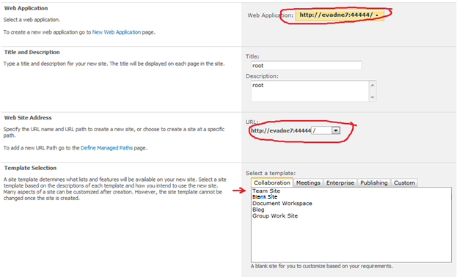

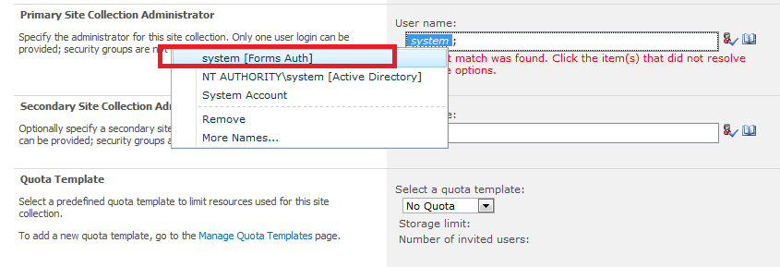

At this point you can test and verify if the web service is discoverable, by navigating to http://MyServer/_vti_bin/KispSharePointService.asmx

**6) Turn on Self-Service Site Creation**

**----------------------------------------------------------**

**Don’t need to anymore**

- go to SharePoint 2010 Central Administration > [Application Management](http://evadne7:17076/applications.aspx) > [Manage web applications](http://evadne7:17076/_admin/WebApplicationList.aspx)

- highlight your site and click Self-Service Site Creation on ribbon

- turn on and click ok

